LAB CYCLE 1

1. Prepare a short note on the following hardware components.

a. Motherboard

A motherboard is a circuit board inside general-purpose computing systems, including personal computers, smart televisions, smart monitors, and other similar devices, which supports communication between different electrical components and houses components such as the CPU, memory etc

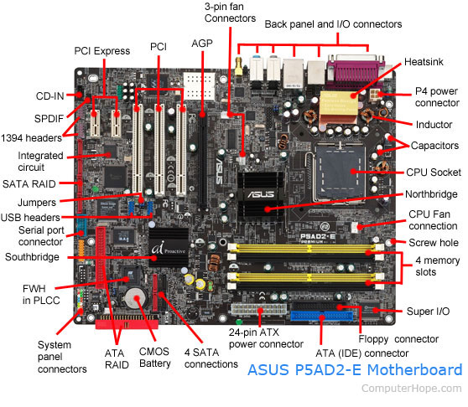

b. Internal storage devices

Internal storage refers to the built-in memory found within electronic devices such as smartphones, [tablets](https://differencedigest.com/health/medicine/what-is-the-difference-between-capsules-and-tablets/), laptops, and desktop computers. It provides quick access to data without the [need](https://differencedigest.com/lifestyleliving/life/what-is-the-difference-between-need-and-want-in-a-relationship/) for additional [hardware](https://differencedigest.com/science/computers/what-is-the-difference-between-software-and-hardware/).

i. RAM- different types

The full form of RAM is Random Access Memory. The information stored in this type of memory is lost when the power supply to the PC or laptop is switched off. The information stored in RAM can be checked with the help of BIOS. It is generally known as the main memory or temporary memory or cache memory or volatile memory of the computer system.

Integrated RAM chips are available in two forms:

* [SRAM (Static RAM)](https://www.geeksforgeeks.org/difference-between-sram-and-dram/)

The [SRAM](https://www.geeksforgeeks.org/sram-full-form/) memories consist of circuits capable of retaining the stored information as long as the power is applied. That means this type of memory requires constant power. SRAM memories are used to build [Cache Memory](https://www.geeksforgeeks.org/cache-memory/).

* [DRAM (Dynamic RAM)](https://www.geeksforgeeks.org/difference-between-sram-and-dram/)

[DRAM](https://www.geeksforgeeks.org/dram-full-form/) stores the binary information in the form of electric charges applied to capacitors. The stored information on the capacitors tends to lose over a period of time and thus the capacitors must be periodically recharged to retain their usage. DRAM requires refresh time. The main memory is generally made up of DRAM chips

ii. ROM

ROM stands for Read-Only Memory. It is a [non-volatile memory](https://www.geeksforgeeks.org/why-rom-is-called-non-volatile-memory/) that is used to store important information which is used to operate the system. As its name refers to read-only memory, we can only read the programs and data stored on it. It is also a [primary memory](https://www.geeksforgeeks.org/primary-memory/) unit of the [computer](https://www.geeksforgeeks.org/basics-of-computer-and-its-operations/) system. It contains some electronic fuses that can be programmed for a piece of specific information. The information stored in the ROM in binary format. It is also known as permanent memory.

**Types of Read-Only Memory (ROM)**

1. [PROM (Programmable Read-Only Memory)](https://www.geeksforgeeks.org/prom-full-form/)
2. [EPROM (Erasable Programmable Read Only Memory)](https://www.geeksforgeeks.org/eprom-full-form/)
3. [EEPROM (Electrically Erasable Programmable Read Only Memory)](https://www.geeksforgeeks.org/eeprom-full-form/)
4. MROM (Mask Read Only Memory)

**1. PROM (Programmable read-only memory):** It can be programmed by the user. Once programmed, the data and instructions in it cannot be changed.

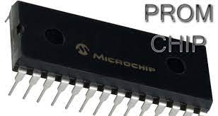

**2. EPROM (Erasable Programmable read-only memory):** It can be reprogrammed. To erase data from it, expose it to ultraviolet light. To reprogram it, erase all the previous data.

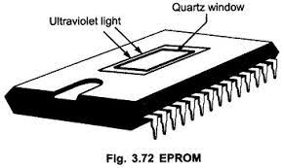

**3. EEPROM (Electrically erasable programmable read-only memory):** The data can be erased by applying an electric field, with no need for ultraviolet light. We can erase only portions of the chip.

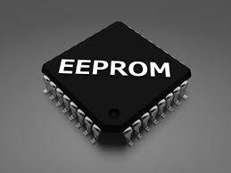

**4. MROM(Mask ROM):** Mask ROM is a kind of read-only memory, that is masked off at the time of production. Like other types of ROM, mask ROM cannot enable the user to change the data stored in it. If it can, the process would be difficult or slow.

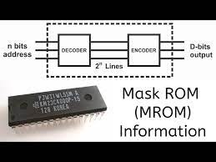

iii. Hard Disk

A [hard disk](https://www.javatpoint.com/hdd) is also known as a hard drive or fixed disk. It is said to be rigid magnetic disc that stores data. It is located within a drive unit. Hard disk is a non-volatile storage device that contains platters and magnetic disks rotating at high speeds. Non-volatile means the data retains when the computer shuts down.

c. SMPS

SMPS stands for Switched-Mode Power Supply. It is an electronic power supply that uses a switching regulator to convert electrical power efficiently. It is also known as Switching Mode Power Supply. It is power supply unit (PSU) generally used in computers to convert the voltage into the computer acceptable range.

This device has the power handling electronic components that converts electrical power efficiently. Switched Mode Power Supply uses a great power conversion technique to reduce overall power loss.

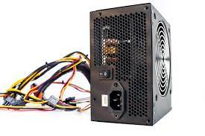

d. daughter cards

Alternatively called a **piggyback board** and **daughter board**, a **daughterboard** is an [expansion board](https://www.computerhope.com/jargon/e/expacard.htm) that connects directly to the [motherboard](https://www.computerhope.com/jargon/m/mothboar.htm) and gives added functionality (e.g., [modem](https://www.computerhope.com/jargon/m/modem.htm)). Today, these boards are not found or used in [desktop](https://www.computerhope.com/jargon/d/desktop.htm) computers. They were replaced with [ISA](https://www.computerhope.com/jargon/i/isa.htm) (Industry Standard Architecture) cards, [PCI](https://www.computerhope.com/jargon/p/pci.htm) (peripheral component interconnect) cards, and [onboard](https://www.computerhope.com/jargon/o/onboard.htm) options. However, some [laptops](https://www.computerhope.com/jargon/l/laptop.htm) still use these boards.

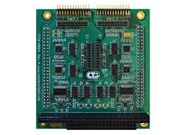

e. Bus slots

Alternatively known as a **expansion slot** or **expansion port**, an **expansion slot** is a connection or port inside a [computer](https://www.computerhope.com/jargon/c/computer.htm) on the [motherboard](https://www.computerhope.com/jargon/m/mothboar.htm) or [riser card](https://www.computerhope.com/jargon/r/risecard.htm). It provides an installation point for a hardware expansion card to be connected. For example, if you wanted to install a new video card in the computer, you'd purchase a video expansion card and install that card into the compatible expansion slot.

Today, the most commonly used expansion slot used and found on computer motherboards is the [PCI Express](https://www.computerhope.com/jargon/p/pciexpre.htm) expansion slot.

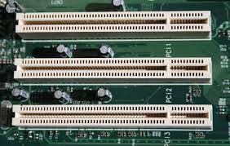

f. Interfacing ports

An **interfacing port** serves as a crucial link between a computer and external devices. These physical docking points allow seamless communication between the computer and peripherals. Common types of ports include **USB ports** (for connecting devices like mice, keyboards, and printers), **VGA ports** (for linking monitors), **Ethernet ports** (for network communication), and **audio sockets** (for microphones and speakers). These ports enhance a computer’s versatility, allowing it to adapt to various needs and are usually located on the exterior of the computer for easy connection or disconnection of devices without opening the case .

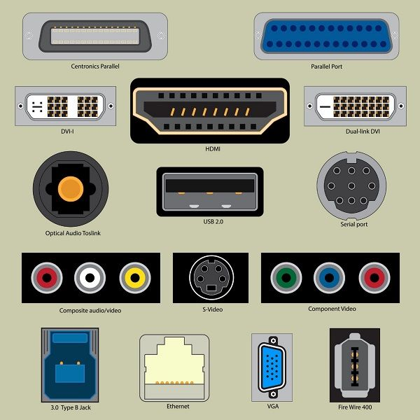

2. Write the specification for a desktop computer.

Desktop Computer Specification  
1. Processor (CPU):

* Intel Core i5 or AMD Ryzen 5 series.
* Speed: 2.5 GHz or higher.

2. Memory (RAM):

* 8 GB DDR4 RAM.

3. Storage:

* 256 GB SSD.

4. Graphics Processing Unit (GPU):

* Integrated graphics or dedicated GPU with 2 GB VRAM.

5. Motherboard:

* Standard ATX or Micro-ATX.

6. Operating System:

* Windows 10 Home 64-bit.

7. Connectivity:

* Gigabit Ethernet, Wi-Fi (802.11ac), Bluetooth 4.2.

8. Ports:

* USB 3.0/3.1 Gen 1 ports, HDMI, DisplayPort.

9. Optical Drive:

* None (external drive optional).

10. Power Supply Unit (PSU):

* 400W or higher.

11. Cooling System:

* Stock CPU cooler, case fans.

12. Case:

* Mid-tower case with adequate airflow.

13. Accessories:

* Standard keyboard, mouse, and speakers.

14. Warranty:

* 1-year limited warranty.

Note: This specification provides a balance between performance, affordability, and functionality, suitable for general computing tasks, light gaming, and multimedia consumption.

3. Write the specification for a server computer.

Server Computer Specification  
1. Processor (CPU):

* Intel Xeon or AMD EPYC series.
* Quad-core or higher, 2.5 GHz or faster.

2. Memory (RAM):

* 16 GB ECC DDR4 RAM.

3. Storage:

* 500 GB NVMe SSD (for operating system).
* 2 TB SATA HDD (for data storage).

4. Network Interface:

* Dual Gigabit Ethernet ports.

5. Operating System:

* Windows Server 2019 or Linux (e.g., CentOS, Ubuntu Server).

6. Remote Management:

* BMC for remote monitoring.

7. Redundancy and Reliability:

* Hot-swappable components.
* ECC memory.

8. Security Features:

* TPM for data protection.
* Firmware security measures.

9. Cooling System:

* Redundant cooling fans.

10. Rack Mountability:

* 1U or 2U rack-mount form factor.

11. Remote Access:

* Remote access software.

12. Warranty and Support:

* Extended warranty options.
* 24/7 technical support.

Note: This specification provides a reliable server setup suitable for small to medium-sized businesses or enterprise applications. Adjustments can be made based on specific requirements and scalability needs.

4. Write short note on the following.

a. Operating System

Operating System lies in the category of system software. It basically manages all the resources of the computer. An operating system acts as an interface between the software and different parts of the computer or the computer hardware. The operating system is designed in such a way that it can manage the overall resources and operations of the computer.

b. Linux

Linux is the best-known and most-used [open source](https://opensource.com/resources/what-open-source) operating system. As an operating system, Linux is software that sits underneath all of the other software on a computer, receiving requests from those programs and relaying these requests to the computer’s hardware.

c. Ubuntu

Ubuntu is a Linux-based operating system. It is designed for computers, smartphones, and network servers. The system is developed by a UK based company called Canonical Ltd. All the principles used to develop the Ubuntu software are based on the principles of Open Source software development.

d. Virtual Machine

A virtual machine (VM) is a digital version of a physical computer. Virtual machine software can run programs and operating systems, store data, connect to networks, and do other computing functions, and requires maintenance such as updates and system monitoring.

e. Kernel

The kernel is the core component of an operating system that acts as a bridge between software applications and the computer's hardware. It manages system resources, including CPU, memory, input/output devices, and file systems, and provides essential services such as process management, memory management, device drivers, and system calls. Essentially, the kernel is responsible for coordinating all operations within the operating system and ensuring that software programs can interact with hardware efficiently and securely.

f. Shell

A shell is a command-line interface that allows users to interact with an operating system by typing text commands. It interprets these commands and executes them, enabling users to perform various tasks such as navigating the file system, launching programs, and managing processes. Shells can also include features like scripting capabilities, command history, and customization options. In essence, the shell serves as a user's primary interface to control and manipulate the operating system and its resources.

g. Terminal

The Linux terminal, also known as the command-line interface (CLI), is a text-based interface used for interacting with the operating system. Users input commands via text, and the system responds with text-based output. It provides access to a wide range of powerful tools and utilities for tasks such as file management, system administration, software installation, and programming. The terminal offers features like command history, tab completion, and shell scripting, enabling users to efficiently navigate their systems and automate tasks.

h. Bash

Bash, short for "Bourne Again Shell," is a popular Unix shell and command language interpreter. It is the default shell for most Linux distributions and is widely used in Unix-like operating systems. Bash provides users with a command-line interface to interact with the operating system, allowing them to execute commands, run scripts, and automate tasks. It supports features such as command history, tab completion, variables, loops, conditionals, and functions, making it a powerful tool for both interactive use and scripting purposes. Bash is highly customizable and extensible, offering users the flexibility to tailor their command-line environment to their needs.

i. Shell scripting

Shell scripting involves writing scripts using commands specific to a shell (like Bash), enabling automation of tasks and management of system configurations in Unix-like environments, enhancing productivity and efficiency.

5.Steps to create a Shell Script in linux.

Here are the steps to create a shell script in Linux:

* Create a new file: Use the touch command to create a new shell script file (e.g., my_script.sh).
* Make it executable: Use chmod +x my_script.sh to grant execution permissions.
* Edit the script: Open the file and add your desired commands (e.g., echo, ls)
* Save the changes.
* Run the script: Execute it with ./my_script.sh.
* Add comments: Use # for comments (ignored during execution).

Use variables: Define and use variables (e.g., $USER).

6. What is the extension of shell script.

The extension commonly used for shell scripts is ".sh". For example, a shell script file might be named "test.sh". However, it's important to note that the extension is not strictly required for a shell script to function.

7. What is shebang ?

A shebang (also known as a hashbang or sha-bang) is the #! character sequence at the beginning of a script in Unix-like operating systems. The shebang is followed by the interpreter or the command that should be used to execute the script.

8. How to put your comments in your script.

Any line starting with a hash (#) becomes a comment. Comment means, that line will not take  
part in script execution.

9.How to execute a shell script.

Open the terminal. Go to the directory where you want to create your script.

* Create a file with **.sh** extension.
* Write the script in the file using an editor.
* Make the script executable with command **chmod +x** <**fileName**>.
* Run the script using ./<**fileName**>.

10.Write a shell script to display your name.

#!/bin/sh  
# Author : Ajo Jojo  
  
echo "What is your name?"  
read PERSON  
echo "Hello, $PERSON"